Experiment 15: Design Turing Machine (TM) Using Simulator to Accept the Language (ww)
Aim
To design and simulate a Turing Machine (TM) that accepts the language
[
L={,ww \mid w \in {a,b}^*,}
]
where the second half of the input string is exactly the same as the first half.
Examples:
- Accepted: aa, abab, babaab, abaaba
- Rejected: ab, aabb, abba

Algorithm
- Start from the leftmost symbol of the input string.
- Determine the midpoint of the string.
- Mark the first unmarked symbol in the first half.
- Move to the corresponding position in the second half.
- Compare the symbols.
- If the symbols match, mark them and return to the beginning.
- Repeat the process until all symbols are compared.
- If all corresponding symbols match, accept the string.
- If any mismatch occurs or the lengths are unequal, reject the string.

Procedure
- Open the Turing Machine simulator (e.g., JFLAP).
- Create the required states.
- Mark the initial state as the start state.
- Add transitions to identify and mark symbols in the first half.
- Move to the corresponding symbols in the second half and compare them.
- Mark matching symbols and return to the beginning.
- Repeat until all symbols are checked.
- If every symbol in both halves matches, move to the accept state; otherwise, move to the reject state.
- Test the machine with valid and invalid input strings.

Input
abab
(Here, w = ab, so ww = abab.)

Output
Input : abab
Output : Accepted
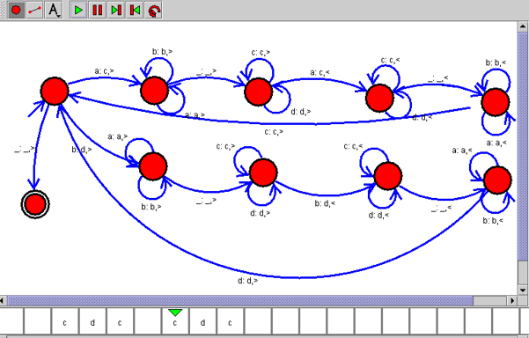

Result
Thus, the Turing Machine (TM) was successfully designed and simulated to accept the language *L = { ww | w ∈ {a, b} }**. The machine correctly accepted input strings in which the second half is identical to the first half and rejected all other strings.

